**Step 1:** User logged in to Thycotic using window credentails:

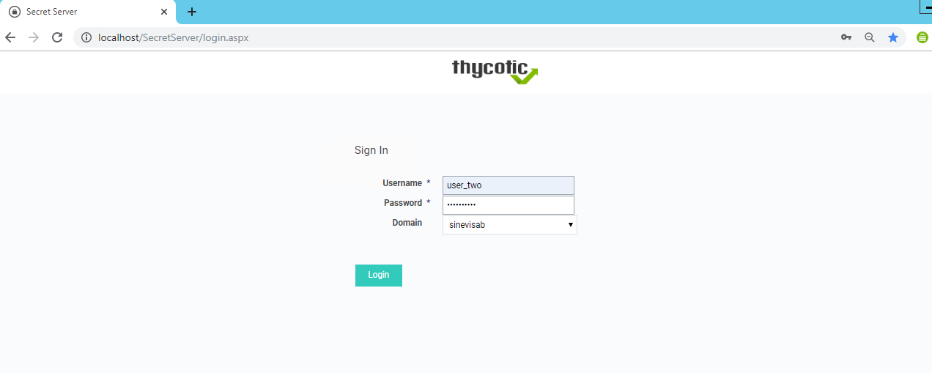

Step 2: After logging in below landing page with all secrets will be shown to user for which he/she will have access. User will click on desired secret.

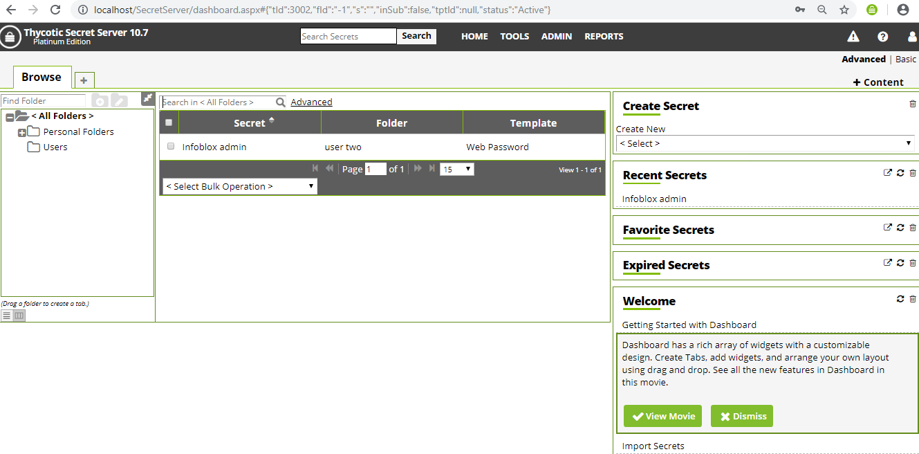

Step 3: Click on Web Password launcher icon will redirect user to Infoblox login page with filled credentails as shown:

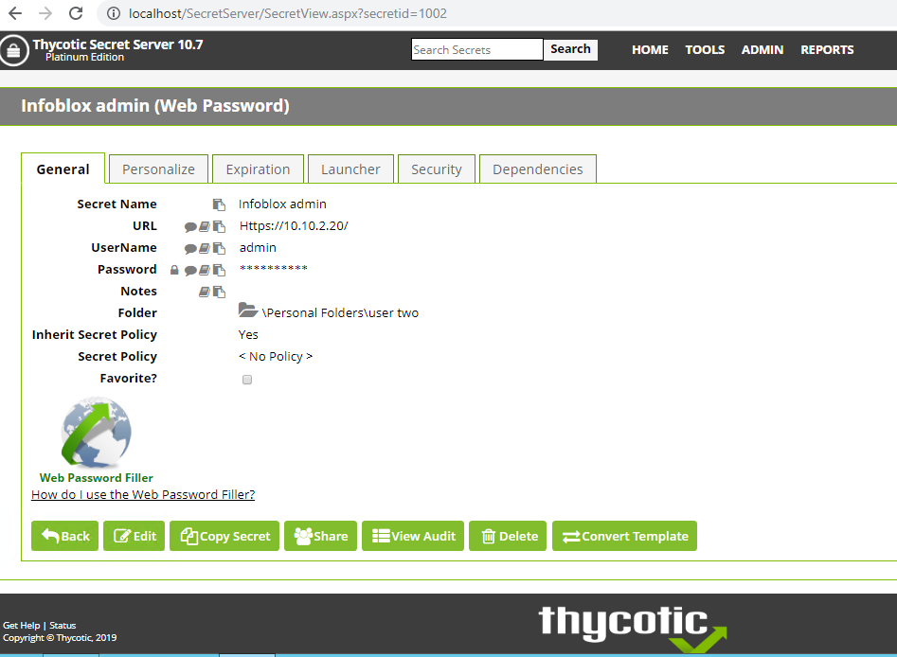

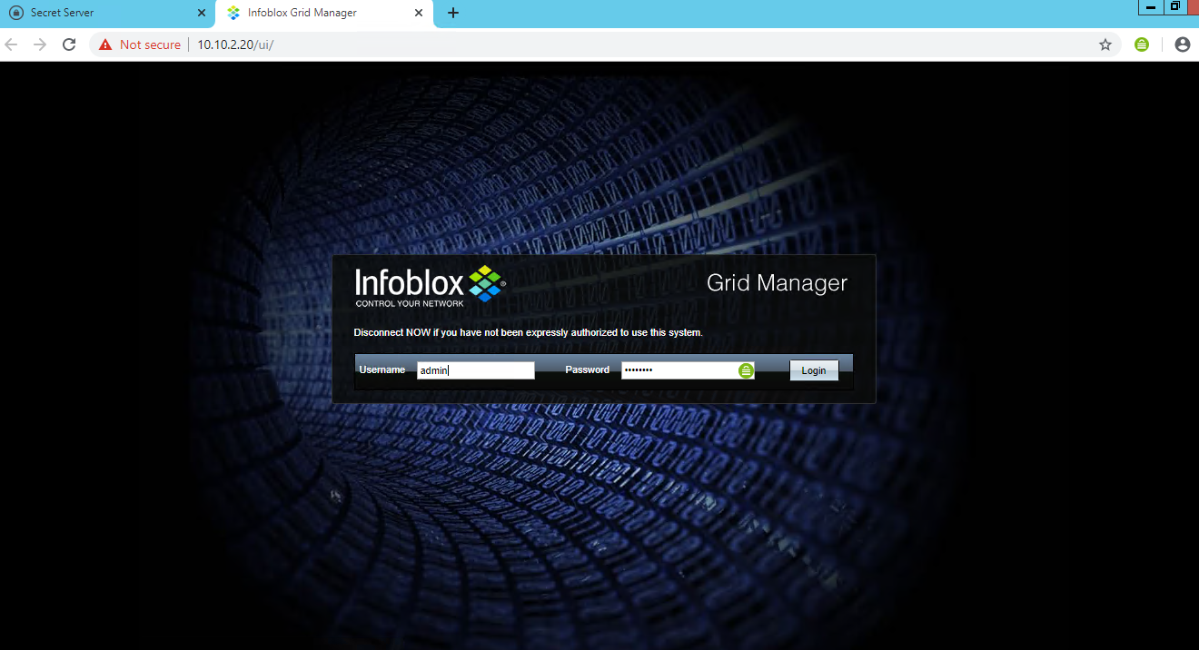

Step 5: User get access to Infoblox GUI as shown:

